If you use window & putty. You need convert pem-file to ppk-file.

To make it open putty folder and run PuTTYgen  
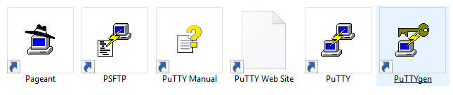

Choose Conversion -> Import Key. Choose your pem file in Choose file menu.

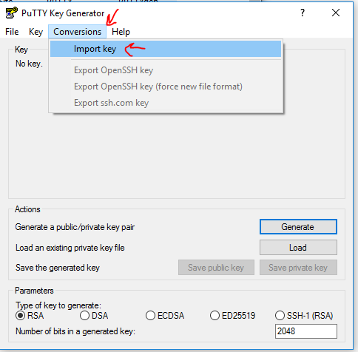

Press Save private key

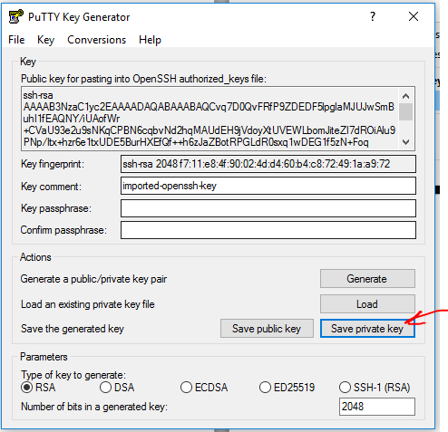

If you don`t type password - you will see warning

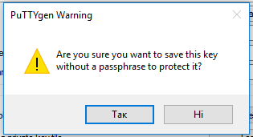

Press Yes – it is OK for learning purposes.

Remember where you save ppk file.

Close PuTTYgen.

Open Pageant.

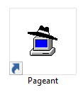

You shall see Pageant icon in tray

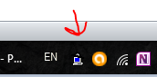

Right click on Agent icon and add SSH key.

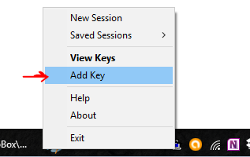

Find your ppk file and choose it.

That is it – key will be automatically handled when you connect to Instance servers via SSH.